Ex.no:4 | EXPLORATORY DATA ANALYSIS (EDA) – DATA INSPECTION, FILTERING, STATISTICAL ANALYSIS AND CORRELATION

Aim:
To perform data inspection, filtering, grouping, aggregation, descriptive statistical analysis, and correlation analysis using Pandas and visualize the results using Matplotlib.
Algorithm:
- Import the required Pandas, NumPy and Matplotlib libraries.
- Read the stud_data.csv file using Pandas.
- Display the dataset and inspect the first few records.
- Find the number of rows and columns and display the data types.
- Generate the statistical summary of the dataset.
- Filter the students based on marks and attendance conditions.
- Sort the student records based on marks and attendance.
- Group the data based on department and calculate average marks and attendance.
- Calculate mean, median, minimum, maximum and standard deviation of marks.
- Calculate the correlation between marks and attendance.
- Create bar chart, line chart, scatter plot, histogram and box plot using Matplotlib.
- Display the results and interpret the obtained data.

Program:
import pandas as pd
import numpy as np
import matplotlib.pyplot as pl
# Read dataset
df = pd.read_csv("stud_data.csv")
# Display dataset
print(df)
# Display first five records
print(df.head())
# Display shape
print(df.shape)
# Display data types
print(df.dtypes)
high_sleep = df[df["Sleep Duration"] > 7]
print(high_sleep)
female = df[df["Gender"] == "Female"] print(female)
sorted_df = df.sort_values( by="Sleep Duration", ascending=False
)
print(sorted_df)
print("Mean =",
df["Sleep Duration"].mean()) print("Median =",
df["Sleep Duration"].median()) print("Mode =")
print(df["Sleep Duration"].mode()) print("Standard Deviation =",
df["Sleep Duration"].std())
print(df.describe())
gender_avg = df.groupby( "Gender"
)["Sleep Duration"].mean() print(gender_avg)
corr = df[[
"Sleep Duration", "Quality of Sleep"
]].corr() print(corr)
import matplotlib.pyplot as plt plt.figure(figsize=(6,4))

plt.scatter(
df["Sleep Duration"], df["Quality of Sleep"]
)
plt.xlabel("Sleep Duration") plt.ylabel("Quality of Sleep") plt.title("Sleep Duration vs Quality of Sleep") plt.show()
import matplotlib.pyplot as plt top = df.sort_values(
by="Sleep Duration", ascending=False
).head(10) plt.figure(figsize=(8,5))
plt.bar(top["Person ID"].astype(str), top["Sleep Duration"])
plt.xlabel("Person ID") plt.ylabel("Sleep Duration") plt.title("Top 10 Sleep Duration") plt.show()

Output:
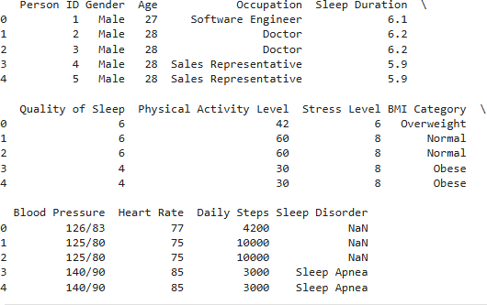
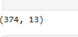
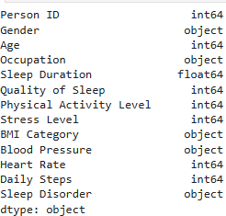

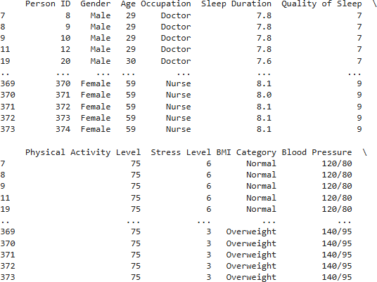

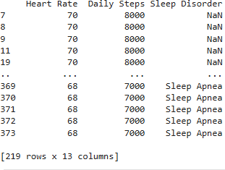
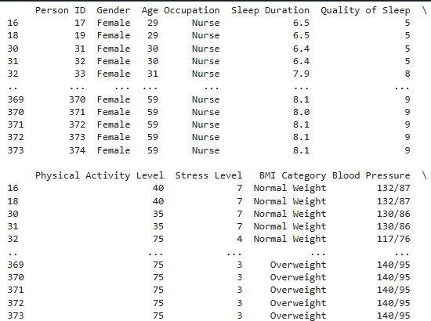

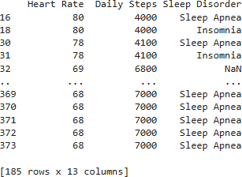
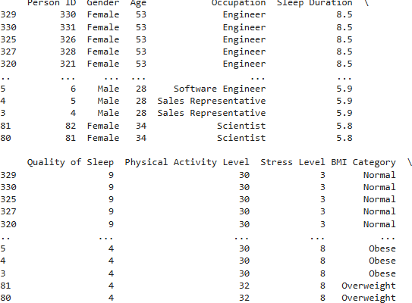
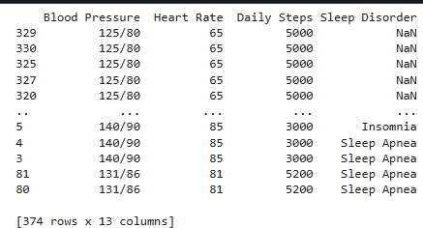

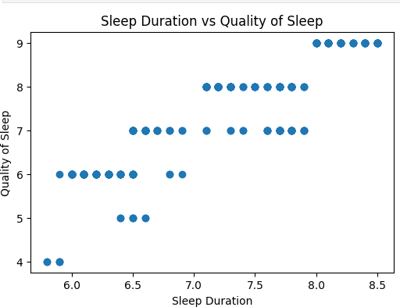
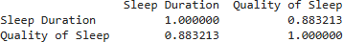
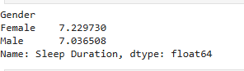
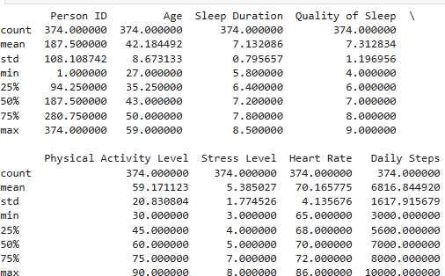
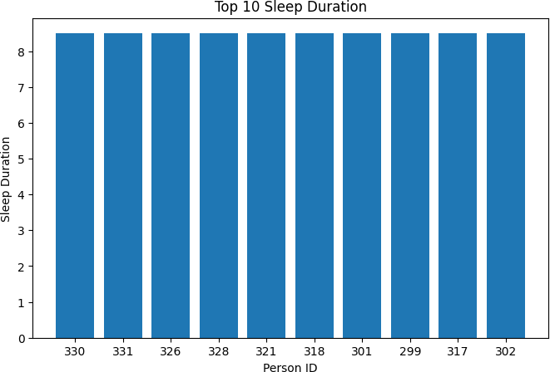

Result:

